REPUBLIC OF TÜRKİYE HASAN KALYONCU UNIVERSITY

FACULTY OF ENGINEERING COMPUTER ENGİNEERİNG DEPARTMENT



CO-OP INTERIM REPORT

SUPERVISOR
MUSTAFA ŞAHİN

BY
NURETTİN MUSTAFA ÖZKAYA

APRIL 2026

ABSTRACT

During my one-month SQL Server training prepared by Adım Yazılım and delivered through the BTK Akademi platform, I had the opportunity to enhance both my theoretical knowledge and practical skills in relational database management systems.
The training program covered a wide range of topics, including database architecture, SQL Server installation and configuration, T-SQL programming, indexing strategies, stored procedures, triggers, transaction management, backup and restore operations, and SQL Server Agent management. Throughout the program, I not only learned how to write efficient SQL queries but also gained experience in designing, optimizing, securing, and maintaining enterprise-level database systems.
In addition to the database training, I applied my knowledge in a practical project by developing a web-based e-commerce platform using Next.js. This allowed me to integrate backend database logic with a modern web interface and gain hands-on experience in full-stack development.
Overall, this training significantly strengthened my backend development foundation, improved my analytical thinking and debugging skills, and enhanced my understanding of database performance optimization and real-world application development.

TABLE OF CONTENTS
ABSTRACT 2
TABLE OF CONTENTS 3
LIST OF TABLES 5
LIST OF FIGURES 6
LIST OF SYMBOLS 7
CHAPTER 1: INTRODUCTION 8
1.1 Information on the Organization 8
1.2 Basic Activities on Adım Yazılım 8
1.3 Purpose of the Training and Project 8
CHAPTER 2: DETAILS OF ACTIVITIES 10
Practice and Application Activities During 1st Week 10
Practice and Application Activities During 2nd Week 11
Practice and Application Activities During 3rd Week 12
Practice and Application Activities During 4th Week 13
Practice and Application Activities During 5th Week 14
Practice and Application Activities During 6th Week 15
Practice and Application Activities During 7th Week 16
Practice and Application Activities During 8th Week 17
CHAPTER 3: INSTRUCTIONS RECEIVING AND GIVING PROCESS 18
3.1 Instructions Receiving Process 18
3.1.1 Instructions Receiving Task 1 18
3.1.2 Instructions Receiving Task 2 18
3.2 Instruction Giving Process 18
CHAPTER 4: DISCUSSION AND CONCLUSION 20
REFERENCES 21
APPENDIX 22
Appendix A – Week 1: SQL Server Setup & System Databases 22
Appendix B – Week 2: T-SQL Fundamentals & Table Design 24
Appendix C – Week 3: Advanced SQL & Indexing 25
Appendix D – Week 4: Transaction Management, Backup and Recovery 26
Appendix E – Week 5: Next.js UI/UX Edge Cases 27
Appendix F – Week 6: Favorites System & Cross-Page Consistency 28
Appendix G – Week 7: Checkout Flow 29
Appendix H – Week 8: Full Workflow & Integration 30

LIST OF TABLES

Table 1. Write here name of the table 11
Table 2. Write here name of the table 13
Table 3. Write here name of the table 14
Table 4. Write here name of the table 16
Table 5. Write here name of the table 18
Table 6. Write here name of the table 22

LIST OF FIGURES

Figure 1 Mssql installation screenshot 22
Figure 2 Windows OS setup screenshot 22
Figure 3 SQL Server installation screenshot 23
Figure 4 SSMS launch screenshot 23
Figure 5 Sample database creation screenshot 24
Figure 6 Orders and OrderDetails Foreign Key Relationship 24
Figure 7 Normalization Overview (Diagram) 25
Figure 8 Clustered vs Non-Clustered Index test results 25
Figure 9 Clustered vs Non-Clustered Index 26
Figure 10 Initial state of the USERS table before transaction 26
Figure 11 Transaction rollback demonstration in the USERS table 27
Figure 12 Product Listing Page with Lazy-Loaded Images (UI Screenshot) 27
Figure 13 Lazy Loading Implementation (Relevant Code Snippet) 28
Figure 14 Favorites on product listing page 28
Figure 15 Product detail page 29
Figure 16 Cart UI 29
Figure 17 Checkout form with addresses 30
Figure 18 Search by Categories 30
Figure 19 Showing products for Search 31

LIST OF SYMBOLS

Abbreviation | Description
HTML | HyperText Markup Language
CSS | Cascading Style Sheets
JS | JavaScript
API | Application Programming Interface
DB | Database
SQL | Structured Query Language
Next.js | React-based web framework
UI | User Interface
UX | User Experience
CRUD | Create, Read, Update, Delete
HTTP | HyperText Transfer Protocol
HTTPS | Secure HyperText Transfer Protocol
JSON | JavaScript Object Notation
REST | Representational State Transfer

CHAPTER 1: INTRODUCTION

1.1 Information on the Organization
Adım Yazılım is a software development company located in Gaziantep Teknopark (Çamtepe Mah. Mahmut Tevfik Atay Bul. No: 4A/10, Şahinbey), specializing in ERP systems as well as web, mobile, and desktop applications. One of the company's flagship products is "Paytahsilat," a digital payment and collection platform that enables firms to manage their financial transactions efficiently. The company operates with a professional team of 10 employees — consisting of 6 computer engineers and 4 support staff — further supported by 3 interns, including myself. The technical staff comprises experienced software engineers and developers specializing in both mobile and web-based ecosystems. Working hours at Adım Yazılım are from 08:30 to 18:00. During my internship, the organization provided a structured and productive environment for learning and applying modern database management and web development technologies.

1.2 Basic Activities on Adım Yazılım
Adım Yazılım focuses on developing scalable software products that cater to the digital transformation needs of various firms. Their core activities include software product development, particularly the creation and maintenance of financial management systems such as Paytahsilat. The company also specializes in database management, designing and optimizing relational database systems (MSSQL) to handle large-scale corporate data. Additionally, Adım Yazılım provides e-commerce and web solutions by developing modern web interfaces integrated with secure backend services, as well as ERP integration services that enable seamless data synchronization between mobile collection systems and existing enterprise resources.

1.3 Purpose of the Training and Project
The primary objective of my internship was to bridge the gap between academic knowledge and industrial application, with a focus on mastering database logic and full-stack web development. In terms of database mastery, the goal was to understand relational database logic and develop strong T-SQL and MySQL coding skills for professional data management. For full-stack implementation, I developed "TradeHub," a web-based e-commerce platform using Next.js, to practice integrating database operations with modern frontend technologies. Furthermore, the internship aimed to provide professional workflow experience, including enterprise-level software development life cycles, backup, recovery, and system optimization processes within a Teknopark environment.

CHAPTER 2: DETAILS OF ACTIVITIES

Practice and Application Activities During 1st Week
During the first week, the focus was on understanding database fundamentals and setting up the development environment.
Initially, I learned the basic concepts of databases, relational models, and client-server architecture. The client-server logic was explained with practical analogies, which helped me clearly understand how database servers handle requests from clients.
After understanding the theoretical foundation, I moved on to the technical setup phase. This process involved installing a virtual machine environment using VMware, followed by the installation of the Windows operating system. Subsequently, SQL Server and SQL Server Management Studio (SSMS) were installed and configured for use throughout the internship.
In addition to the setup process, I learned about the core system databases of SQL Server: master, model, msdb, and tempdb. Understanding the role of these system databases helped me comprehend how SQL Server internally manages configurations, scheduled jobs, temporary data, and metadata.
By the end of the first week, I had a fully operational SQL Server environment and a solid understanding of database architecture.

Practice and Application Activities During 2nd Week
The second week focused heavily on T-SQL fundamentals and relational database design. The topics covered during this week included core SQL data types such as INT, VARCHAR, NVARCHAR, DATETIME, and DECIMAL, along with table creation and the application of Primary Key and Foreign Key constraints. Additionally, NOT NULL and UNIQUE constraints were studied to ensure data integrity.
Query operations were also a major focus of the week. SELECT queries, WHERE conditions, ORDER BY and GROUP BY clauses, as well as the HAVING clause were practiced extensively. Aggregate functions including SUM, COUNT, AVG, MIN, and MAX were applied in various scenarios, and JOIN operations such as INNER JOIN, LEFT JOIN, and RIGHT JOIN were used to retrieve data across multiple related tables.
During this week, I designed sample relational databases such as company and employee management systems. I practiced building relationships between tables using foreign keys and ensured referential integrity throughout the design process.
One of the most important skills I gained was understanding normalization and reducing data redundancy. I also encountered common errors such as constraint violations and datatype mismatches, which significantly improved my debugging capabilities.

Practice and Application Activities During 3rd Week
The third week focused on advanced SQL programming and performance optimization. The topics covered included Clustered and Non-Clustered Indexes, Views, User Defined Functions (both Scalar and Table-Valued), Stored Procedures, and Triggers.
During this week, I learned how indexes significantly affect query performance and conducted tests comparing indexed and non-indexed queries to observe execution time differences. This practical comparison provided a clear understanding of how proper indexing strategies can dramatically improve database efficiency.
I also developed stored procedures for CRUD (Create, Read, Update, Delete) operations, which allowed me to understand how business logic can be centralized within the database layer. This approach promotes code reusability and simplifies application-level development.
Additionally, I implemented triggers for automatic data validation and logging operations. This demonstrated how database-level automation improves data consistency and overall system control. By the end of the third week, my understanding of modular and maintainable database programming had significantly improved.

Practice and Application Activities During 4th Week
The fourth week focused on enterprise-level database management and reliability. The topics covered during this week included Transactions (BEGIN TRANSACTION, COMMIT, ROLLBACK), error handling mechanisms, backup types such as Full, Differential, and Log Backup, as well as restore operations. Additionally, SQL Server Agent, maintenance plans, cursor logic, and a Big Data overview were studied.
During this week, I simulated transaction scenarios to understand atomicity and rollback mechanisms. Learning transaction management deepened my understanding of ACID principles, which are fundamental to ensuring data integrity in enterprise systems.
I also practiced creating backup files and restoring databases to simulate disaster recovery scenarios. This experience was crucial for understanding data security and business continuity planning in real-world environments.
Furthermore, using SQL Server Agent, I learned how to schedule automated jobs and maintenance tasks. This knowledge is essential in real-world enterprise database systems, where routine operations must be performed reliably and without manual intervention. By the end of the fourth week, I had gained a comprehensive understanding of how enterprise-level database systems are maintained and protected.

Practice and Application Activities During 5th Week
The fifth week focused on improving UI/UX robustness and handling edge cases within the Next.js-based e-commerce platform. The topics covered during this week included edge case handling for empty states and no-result scenarios, server-side rendering with render-before-response logic, performance optimization through lazy loading, and ensuring UI consistency across components.
During this week, I improved the overall user experience by handling edge cases such as empty search results or filtered data returning zero items. Instead of leaving blank screens, meaningful UI messages were displayed to guide the user through the interface more effectively.
Performance was also improved by implementing lazy loading for product images in listing components, which significantly reduced loading times when browsing large datasets. This optimization proved particularly beneficial in scenarios involving high volumes of product data.
Additionally, I ensured that product listings and recommendation sections work together without breaking layout consistency. Since all data is fetched on the server side, the UI remains stable and prevents flickering issues that are commonly associated with client-side rendering approaches.
By the end of the fifth week, the importance of server-side rendering in the Next.js App Router was clearly reinforced. Awaiting data before rendering results in a smoother and more reliable user experience, which is a critical requirement for production-grade web applications.

Practice and Application Activities During 6th Week

The sixth week focused on maintaining cross-page consistency and expanding the favorites system across the entire application. The topics covered during this week included state consistency across multiple pages, reusable component design, server-side data handling, and filtering logic for recommendations.
During this week, I extended the favorites feature to work consistently across different pages such as product listings, product details, the favorites page, and the cart page. This required a unified approach to managing favorite states without duplicating logic across components.
To achieve this, I implemented a strategy where favorite item IDs are fetched once per request, converted into a Set data structure, and passed into reusable UI components such as the FavoriteButton. This approach allowed for efficient lookups and consistent UI behavior throughout the application.
Additionally, I enhanced the cart page by adding a "You may also like" recommendation section. This required filtering out items already present in the cart from server-fetched datasets such as best sellers, ensuring that recommendations remained relevant and non-redundant.
Overall, this week focused on applying consistent business logic across multiple routes while maintaining a reusable and clean component architecture. The experience highlighted the importance of centralizing data-fetching logic and designing components with reusability in mind from the outset.

Practice and Application Activities During 7th Week

The seventh week focused on implementing the checkout flow with authentication and server-side calculations. The topics covered during this week included authentication-based routing, server-side calculations for subtotal, shipping, and total amounts, form handling and UI design, as well as user data integration for delivery addresses.
During this week, I developed the checkout page and ensured that only authenticated users could access it. Unauthorized users were redirected to the login page using Next.js routing mechanisms, which provided a secure and seamless navigation experience.
All price calculations, including subtotal, shipping cost, and total amount, were handled entirely on the server side. This approach ensured data consistency and prevented any possibility of manipulation from the client side, which is a critical security requirement in e-commerce applications.
I also integrated user address data retrieved from the database and displayed it in a structured checkout form, allowing users to complete the delivery step efficiently. This integration required careful handling of relational data to ensure accurate and up-to-date address information was presented.
Additionally, I implemented proper handling for empty cart scenarios by displaying a user-friendly message instead of allowing the checkout process to fail silently. By the end of the seventh week, my understanding of secure and reliable transaction flows in e-commerce applications had been significantly strengthened.

Practice and Application Activities During 8th Week
The eighth week focused on validation, testing, and final integration of the entire e-commerce workflow. The topics covered during this week included end-to-end workflow testing, route validation and edge case testing, server-side data consistency verification, and final system integration.
During this week, I tested the complete application workflow, covering product browsing, searching, filtering, pagination, managing favorites, adding items to the cart, and completing the checkout process. This comprehensive testing phase ensured that all major user flows functioned correctly and consistently across the application.
I also validated edge cases such as empty cart, empty favorites list, and pagination limits to ensure that all routes display correct and stable UI states under various conditions. This process reinforced the importance of defensive programming and thorough boundary testing in production-level applications.
Furthermore, I verified that order-related pages render correctly using server-side data, including order status, totals, and detailed line items. Ensuring server-side consistency across these pages was essential for maintaining data accuracy and a reliable user experience.
Finally, I documented the overall system architecture and workflow for the internship report, explaining how Next.js App Router, server-side rendering, and repository-based data management work together to build a scalable and maintainable e-commerce platform. This documentation process provided a valuable opportunity to consolidate and reflect upon the knowledge and skills acquired throughout the entire internship period.

CHAPTER 3: INSTRUCTIONS RECEIVING AND GIVING PROCESS

3.1 Instructions Receiving Process

3.1.1 Instructions Receiving Task 1
Instructions were provided verbally by my supervisor at Adım Yazılım during the morning briefing sessions. Specifically, I was tasked with integrating the MS SQL Server backend with the Next.js frontend for the TradeHub project. Although I understood the core requirements, I needed clarification on how the company's specific repository pattern should be implemented to ensure data security. After a brief technical discussion with the senior developer, I was able to follow the instructions clearly and implement the data fetching logic within the expected deadline.
The main challenge encountered during this task was handling asynchronous data fetching without causing hydration errors in Next.js. This issue was resolved by consulting the official Next.js documentation and reviewing existing code snippets provided by the technical team at Adım Yazılım. As a proof of study, I successfully developed the Product List module, where data is fetched directly from the SQL database using a secure server-side action, ensuring that the user interface updates dynamically without exposing the connection string.

3.1.2 Instructions Receiving Task 2
Instructions for the second task were received via a written task description on the project management tool, in which my supervisor requested a technical report regarding the database schema of the TradeHub platform. The instructions were clear; however, confirmation was needed regarding which normalization level (1NF, 2NF, or 3NF) was preferred for the specific e-commerce tables. Following this clarification, the documentation was prepared according to the company's internal standards and submitted for review within two days. As a proof of study, a detailed Entity-Relationship Diagram (ERD) was prepared for the e-commerce system, documenting the relationships between the Users, Orders, and Products tables and ensuring that all foreign key constraints were correctly defined.

3.2 Instruction Giving Process
During the internship period, I had the opportunity to guide one of the other interns on how to set up the local Next.js development environment and connect it to the shared SQL Server instance. Instructions were delivered verbally while demonstrating the process on screen, followed by a short written guide covering the configuration of environment variables through .env files. The instructions were precise and focused on the installation of necessary dependencies such as mssql and prisma. The intern successfully set up the environment and was able to run the project locally without further assistance. As a proof of study, a Setup Guide was created for the development team, explaining the step-by-step process of configuring database connection strings to ensure that all developers work on the same consistent data structure.

CHAPTER 4: DISCUSSION AND CONCLUSION

The internship process provided through Adım Yazılım and delivered via the BTK Akademi platform significantly contributed to both my academic and professional development, especially in full-stack web development using Next.js.
Throughout this project, I moved beyond basic frontend development and gained a deeper understanding of how modern web applications are structured. I developed a dynamic e-commerce platform using Next.js App Router, where I implemented server-side rendering, repository-based data management, and scalable UI components.
I designed and developed various features such as product listing, dynamic product detail pages, favorites system, cart management, and checkout flow. By integrating backend logic with frontend components, I learned how to build a complete and functional web application.
Additionally, I focused on performance optimization, state consistency across pages, and handling edge cases to ensure a stable and user-friendly interface. Working with server-side data fetching and structured architecture improved both the maintainability and scalability of the project.
This internship strengthened my skills in modern web technologies and enhanced my problem-solving abilities. As a Computer Engineering student, this experience increased my confidence in developing real-world, database-driven web applications and prepared me for future professional projects.

REFERENCES
[1] Adım Yazılım, "SQL Server Training Content." Adım Yazılım. [Online]. Available: https://www.adimyazilim.com.tr/ [Accessed: Apr. 2026].
[2] Microsoft, "SQL Server Official Documentation." Microsoft. [Online]. Available: https://www.microsoft.com/tr-tr/sql-server/ [Accessed: Apr. 2026].
[3] Vercel, "Next.js Official Documentation." Vercel. [Online]. Available: https://nextjs.org/ [Accessed: Apr. 2026].

APPENDIX

Appendix A – Week 1: SQL Server Setup & System Databases

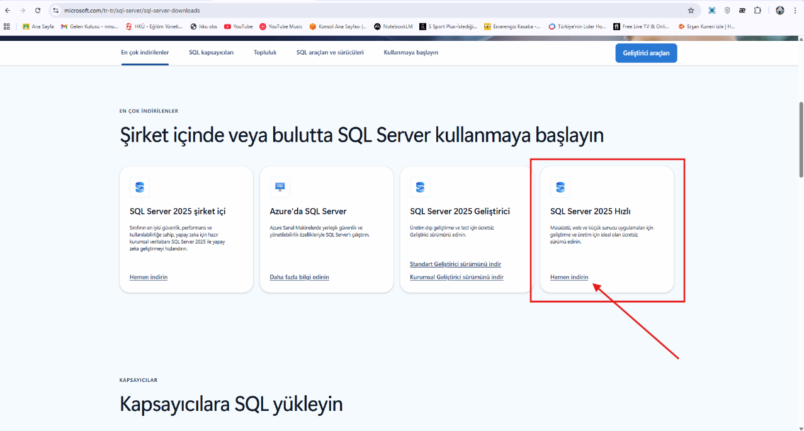
Figure 1 Mssql installation screenshot
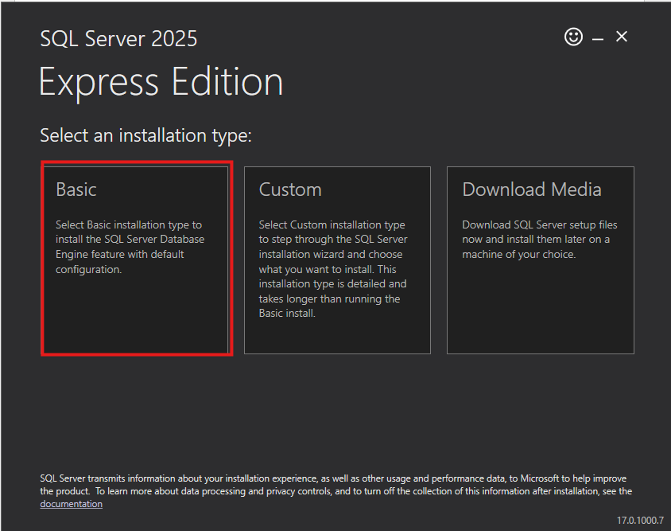
Figure 2 Windows OS setup screenshot
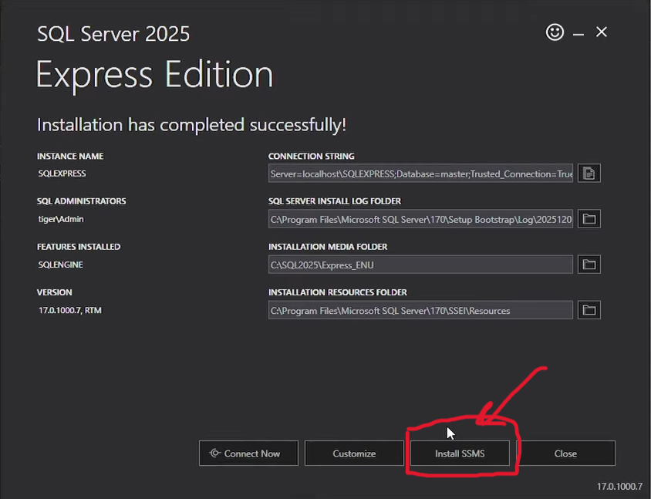
Figure 3 SQL Server installation screenshot
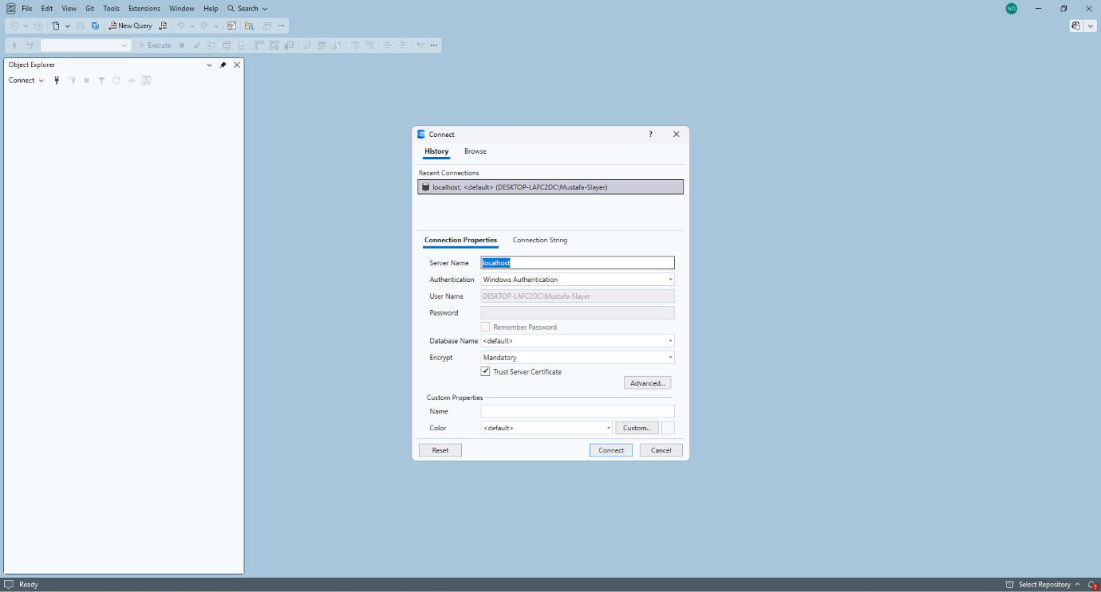
Figure 4 SSMS launch screenshot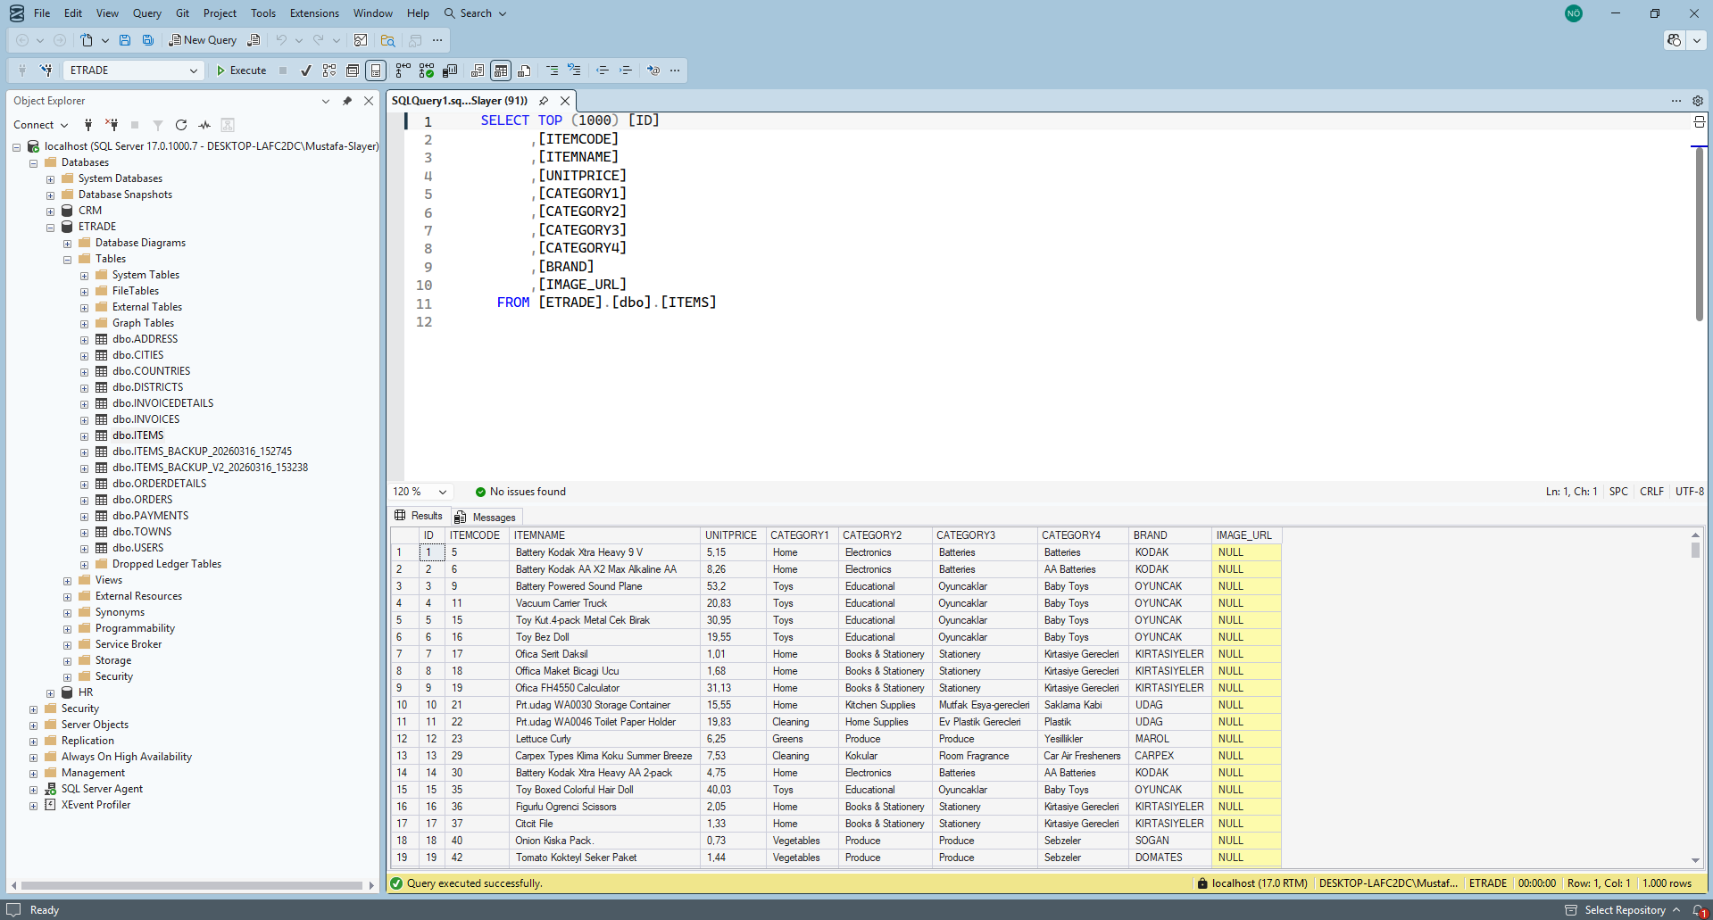
Figure 5 Sample database creation screenshot

Appendix B – Week 2: T-SQL Fundamentals & Table Design

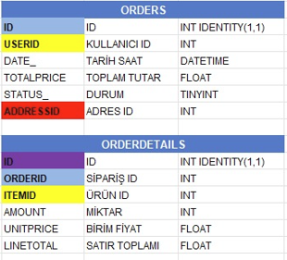
Figure 6 Orders and OrderDetails Foreign Key Relationship
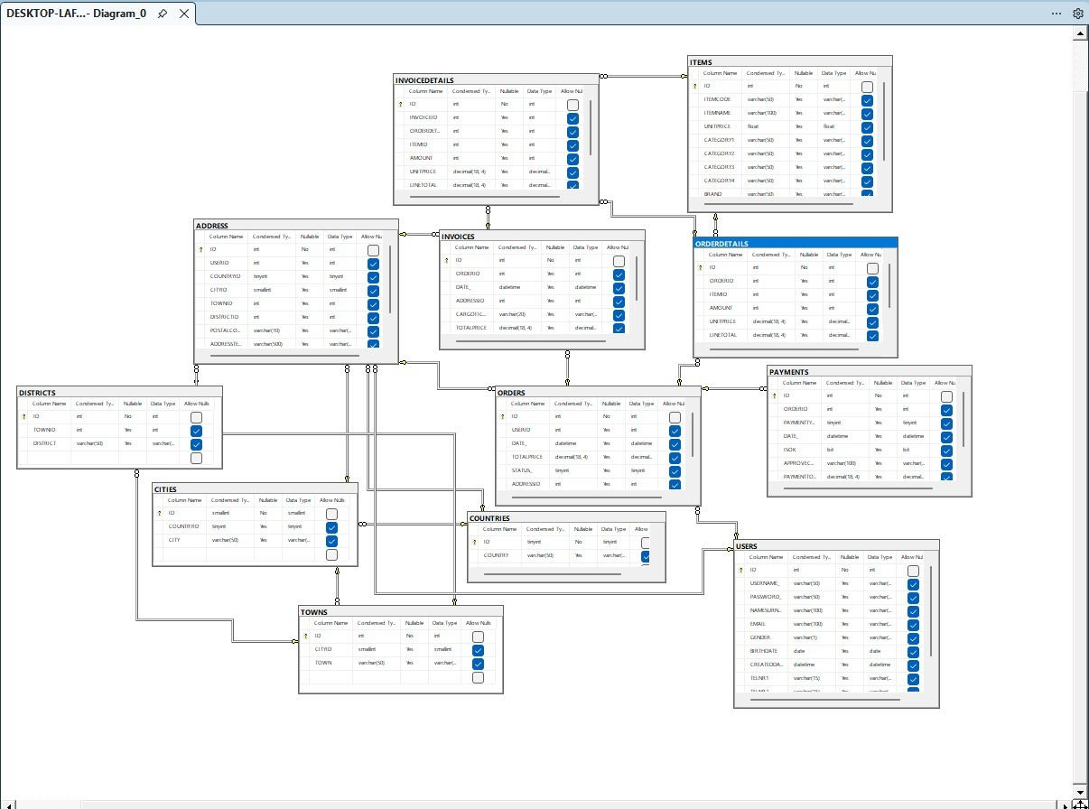
Figure 7 Normalization Overview (Diagram)

Appendix C – Week 3: Advanced SQL & Indexing
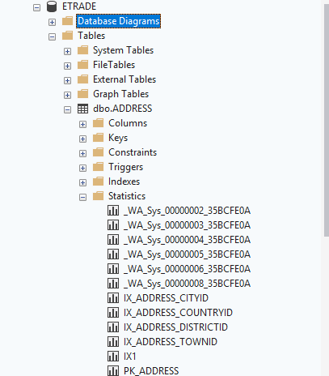
Figure 8 Clustered vs Non-Clustered Index test results
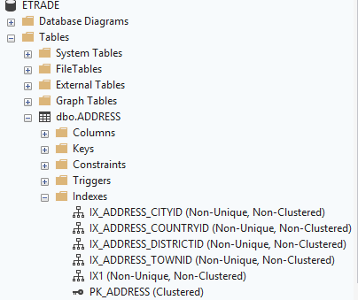
Figure 9 Clustered vs Non-Clustered Index

Appendix D – Week 4: Transaction Management, Backup and Recovery
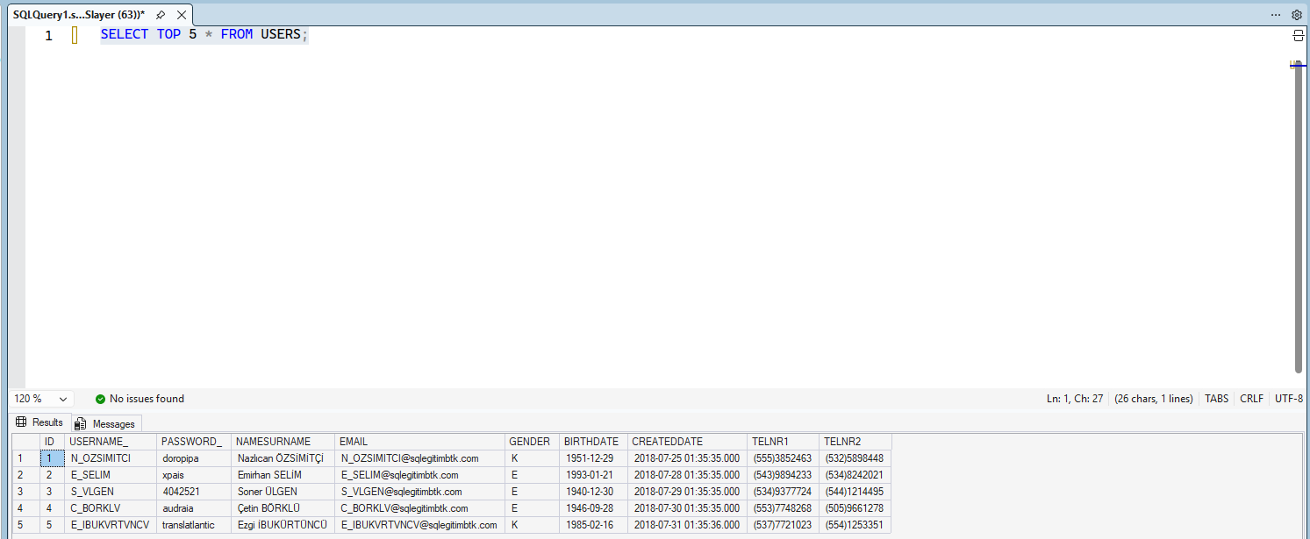
Figure 10 Initial state of the USERS table before transaction

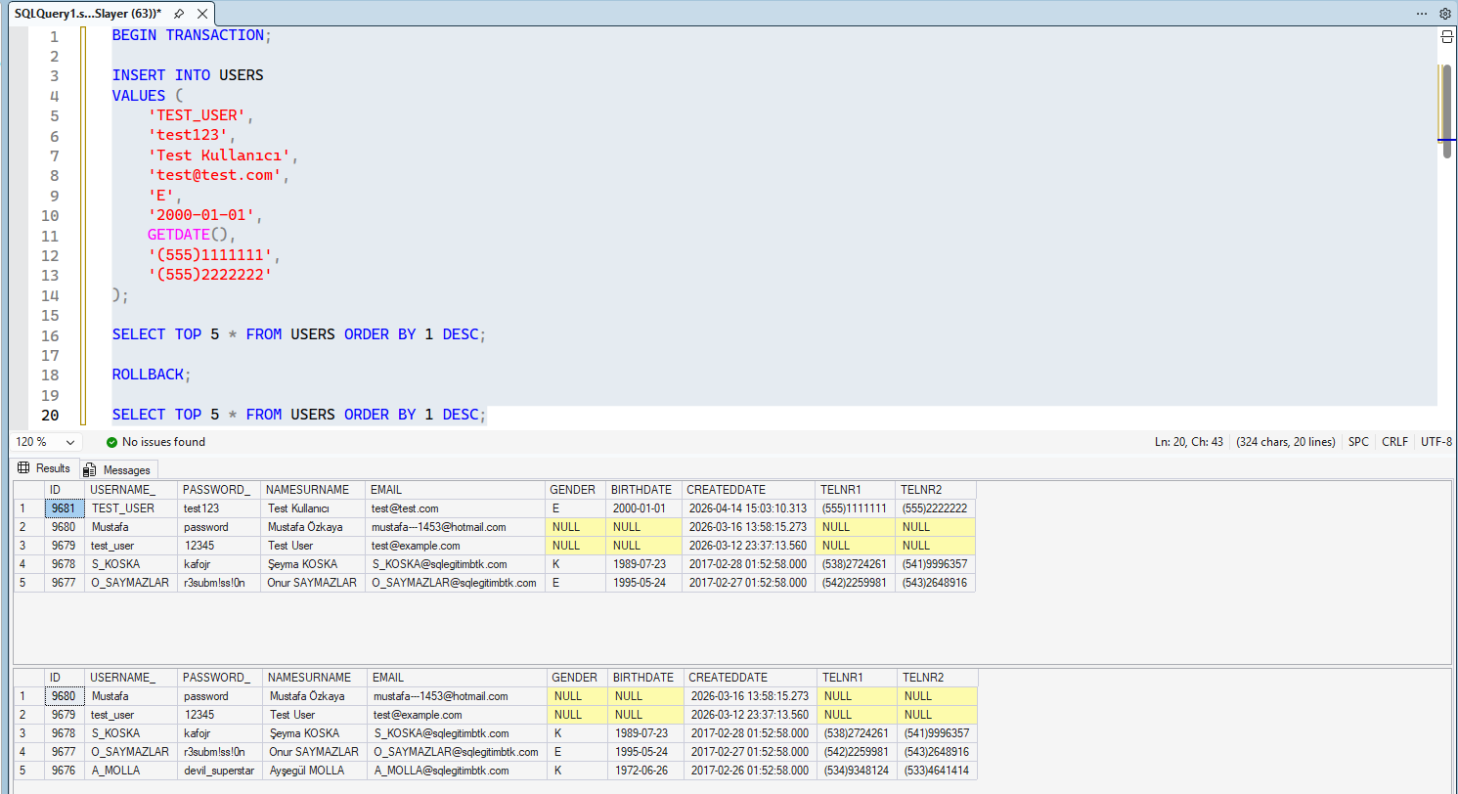
Figure 11 Transaction rollback demonstration in the USERS table

Appendix E – Week 5: Next.js UI/UX Edge Cases
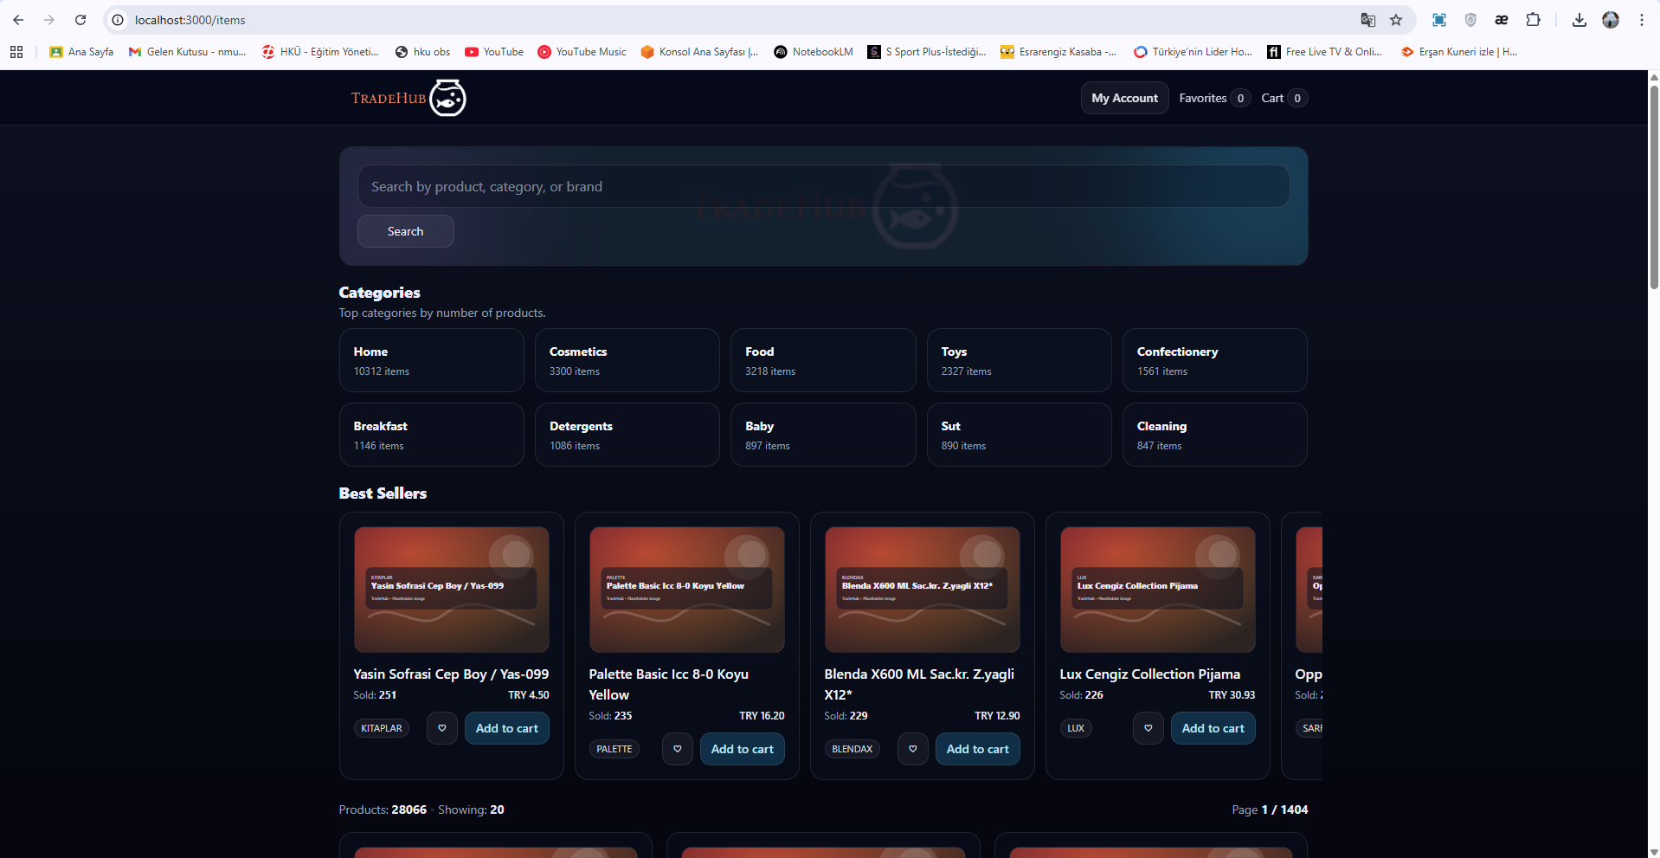
Figure 12 Product Listing Page with Lazy-Loaded Images (UI Screenshot)
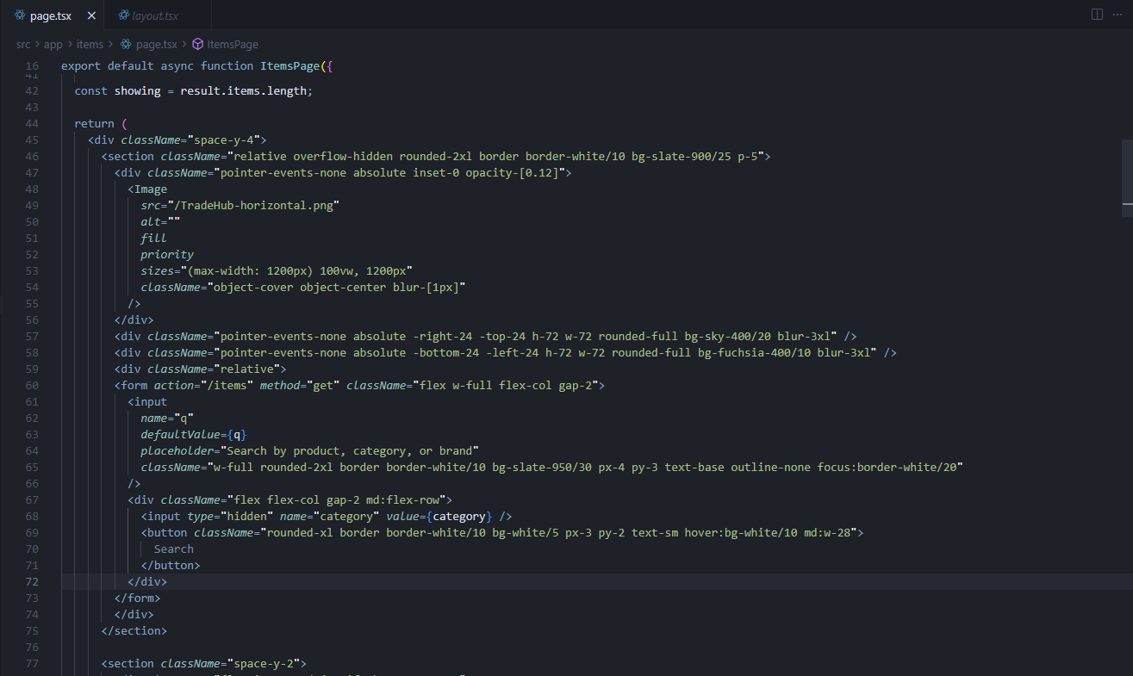
Figure 13 Lazy Loading Implementation (Relevant Code Snippet)

Appendix F – Week 6: Favorites System & Cross-Page Consistency
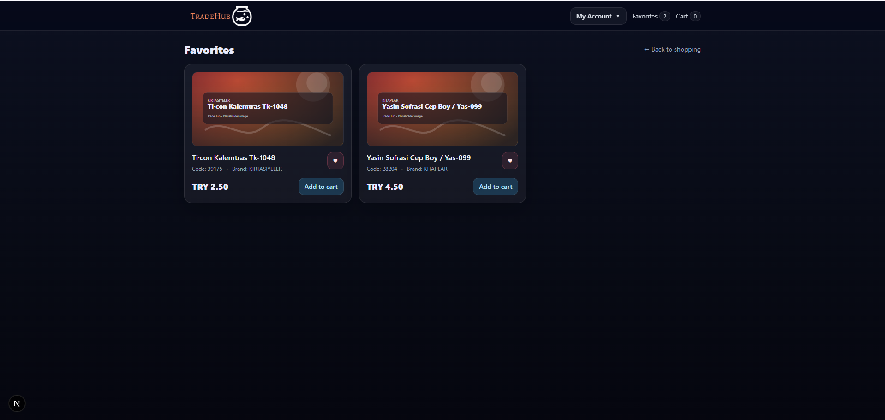
Figure 14 Favorites on product listing page

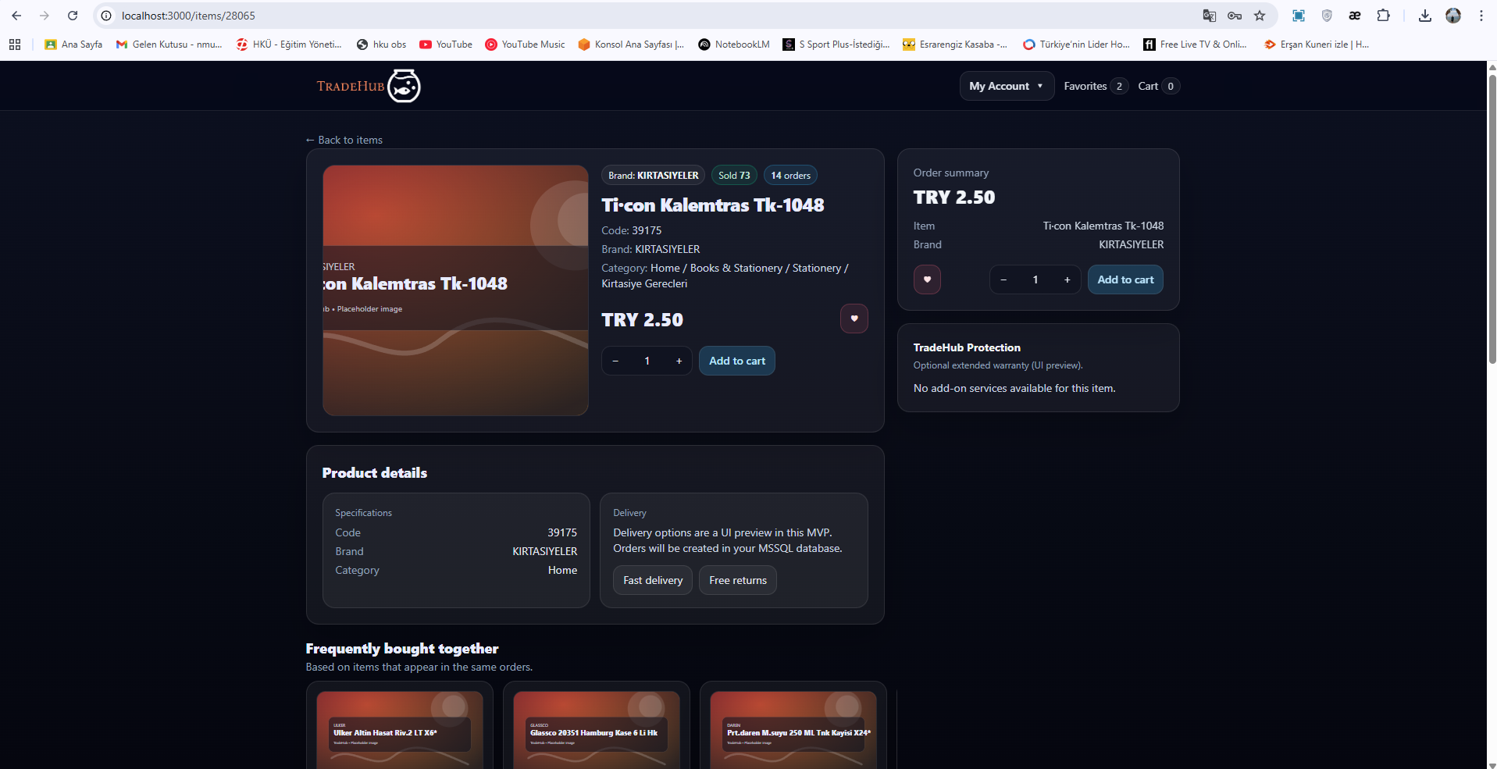
Figure 15 Product detail page

Appendix G – Week 7: Checkout Flow
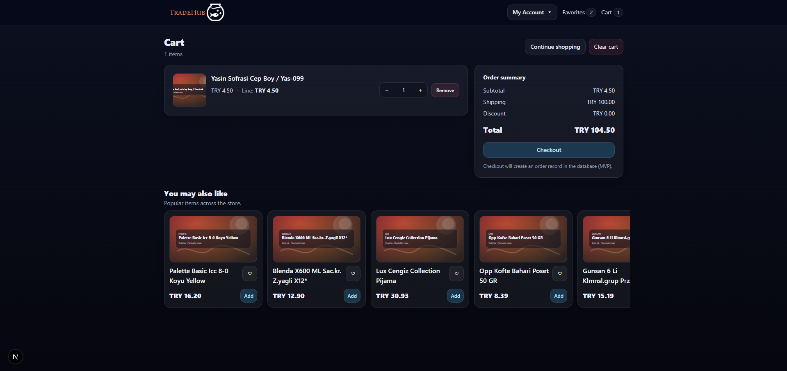
Figure 16 Cart UI

Appendix H – Week 8: Full Workflow & Integration
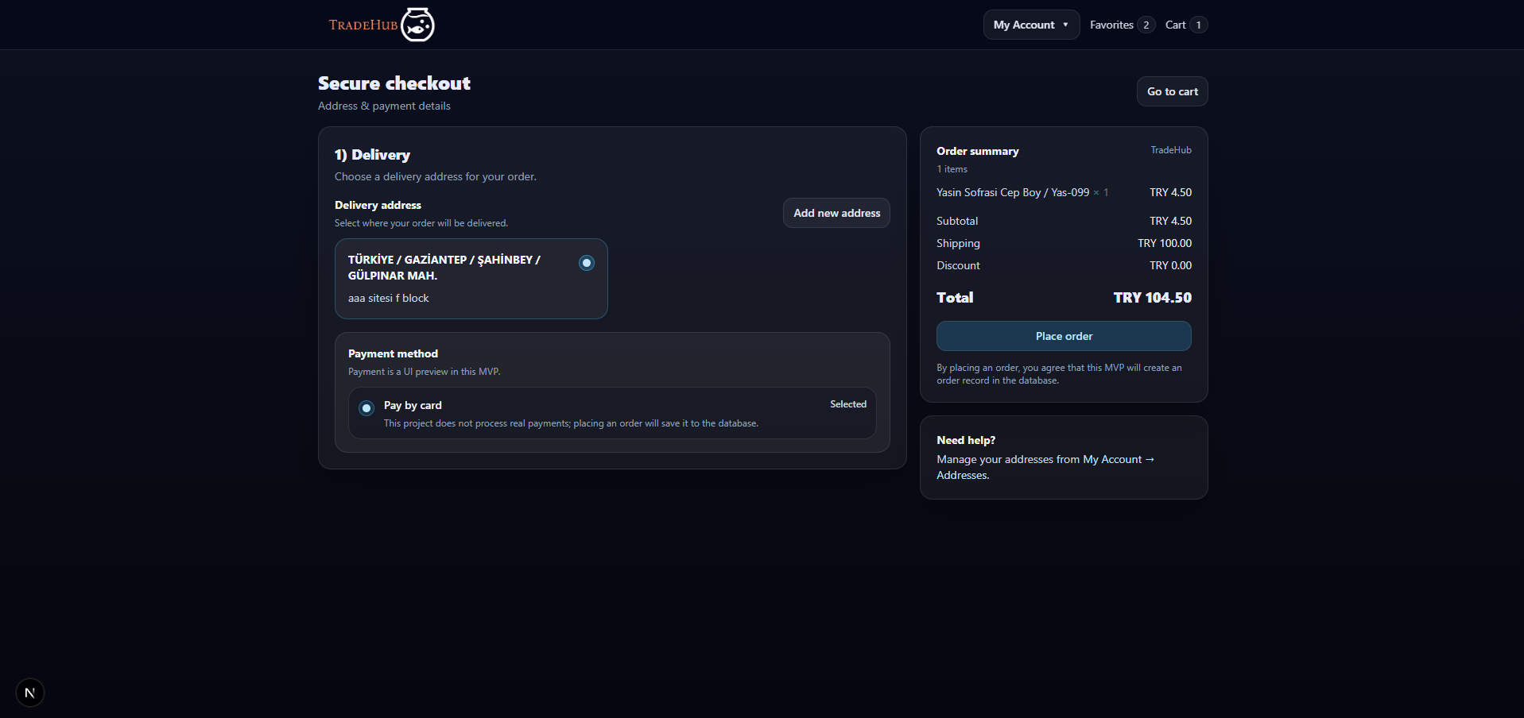
Figure 17 Checkout form with addresses
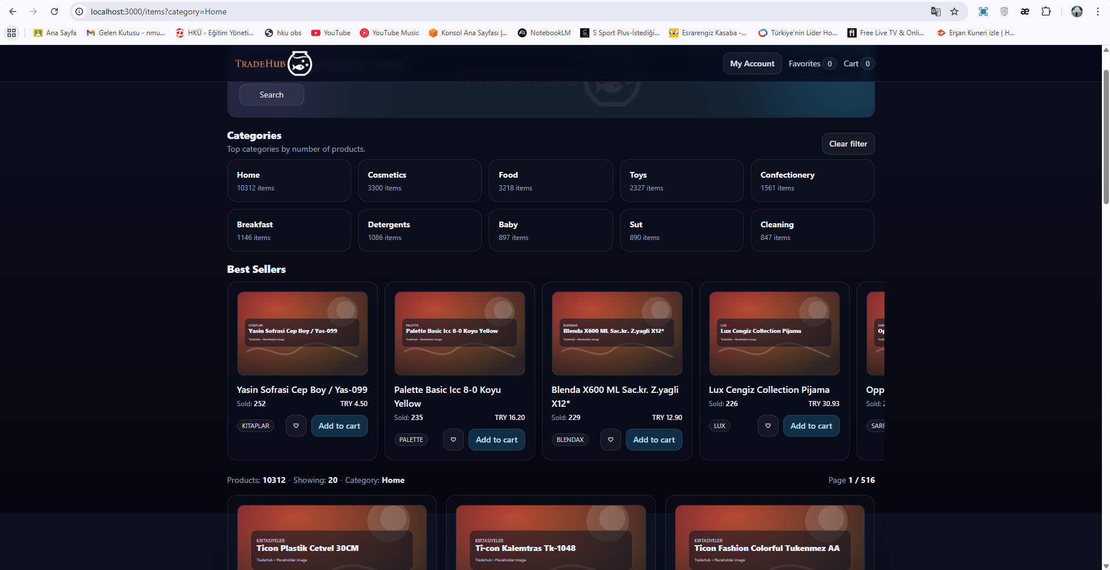
Figure 18 Search by Categories
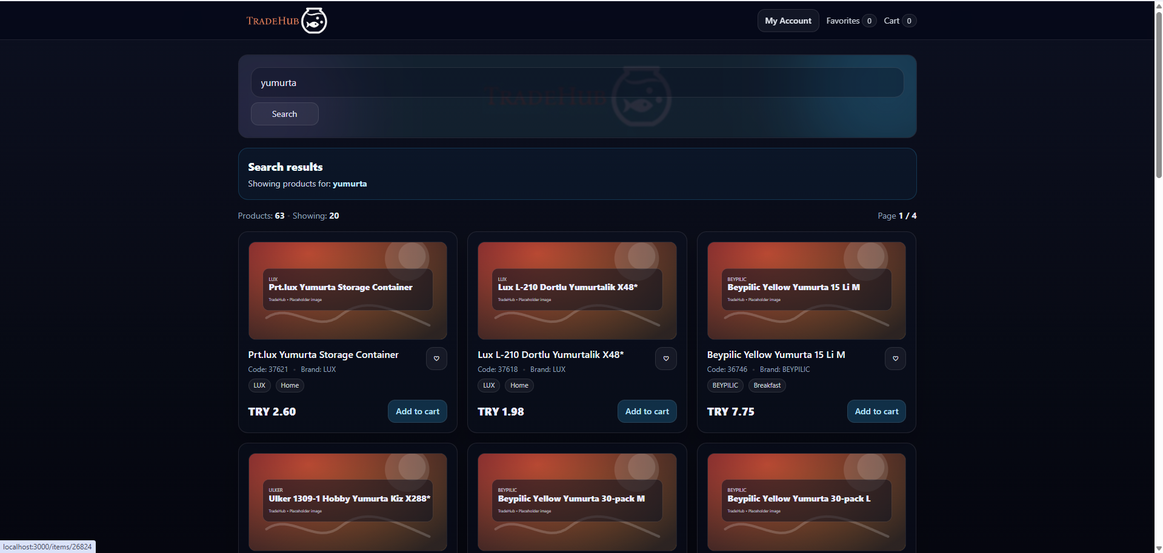
Figure 19 Showing products for Search

